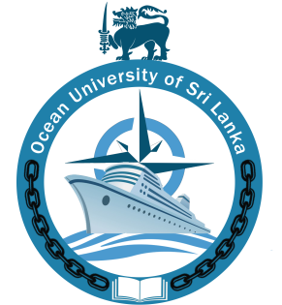

OCEAN UNIVERSITY OF SRI LANKA
VACANCIES
The Ocean University of Sri Lanka seeks suitable candidates for the following Post

- Instructor ICT (on an Assignment Basis).

- QUALIFICATION

1.1 Instructor-ICT (Assignment Basis).
The applicants should have completed a Bachelor’s Degree in Computer Science, Computer Engineering, Software Engineering, Information Technology, or any other related field (Preference will be given to the candidates who possess skills in programming and web development, Network Management,
or
Diploma in above fields with not less than 2 years duration
And
At least 2 years experience in web development, network management, software engineering, and ICT solutions.
With
Strong communication, ability to speak, read and write fluent English, and assist in the production of reports in English.

    - KEY RESPONSIBILITIES:

- Creating website layout/user interfaces and integrating data from various back-end services and databases
- To improve and update software and systems.
- Running regular checks on network and data security
- Developing and implementing IT policy and best practices, guides for the organization
- Overseeing and determining timeframes for major IT projects including system updates, upgrades, migrations, and, outages
- Create and maintain software documentation
- Be responsible for maintaining, expanding, and scaling the website
- Timely response to helpdesk requests from callers and walk-ins; provide remote assistance to ICT-authorized users with ICT problems

- REMUNERATION:
Negotiable

- DURATION: One-year assignment basis and extendable based on performance

- AGE: Should be not less than 18 years and not more than 45 years.

Those who wish to apply should send their Curriculum Vitae (CV)along with copies of relevant academic certificates to reach the Assistant Registrar, Human Resource Development, Ocean University of Sri Lanka, No. 51, Pannananda Mawatha, Mattakkuliya, Colombo 15. Or email wasantha.herath@ocu.ac.lk on or before 8th May 2023.

Registrar
Ocean University of Sri Lanka
No. 51, Pannananda Mawatha, Mattakkuliya, Colombo 15. 25.04.2023

